Instructions:

* This is an open-book final exam.
* Please submit this document only.

**Rubrics**

|  |  |
| --- | --- |
| Window Design (Form Color) | 20% |
| Validations | 20% |
| Transfer file to external text | 20% |
| Algorithm for questions | 20% |
| Zipped Application | 20% |
| Total | 100% |

*Note: the student will ZIP the app and submit this document with the zipped app to module 8.*

**Project (Chapter 13 TKINTER Programming & Text Files)**

**Theme:** Test Form. The student will *make up* the questions, with answers. There will be 5 questions, each is worth 20%.

Create a GUI interface using TKINTER, that will accept the following widgets:

|  |  |  |
| --- | --- | --- |
| **Type** | **Widget** | **Validations** |
| Lastname | Label and Text Field | Cannot enter number values |
| Firstname | Label and Text Field | Cannot enter number values |
| Question #1 | 3 Radio Buttons, one for each question | NA |
| Question #2 | 3 Radio Buttons, one for each question | NA |
| Question #3 | 3 Radio Buttons, one for each question | NA |
| Question #4 | 3 Radio Buttons, one for each question | NA |
| Question #5 | 3 Radio Buttons, one for each question | NA |
| Submit | Button | NA |

When the submit button is pressed, display a message box of the percent correct, with the name.

*Example: John Doe received an 80% test score. (Note: be sure to add the percent symbol)*

Then transfer the results to an external text file. Make sure to change the color of the Window/Form to any color.

**Print screen the message box below here.**

**Print screen the validations for the last and first names below here.**

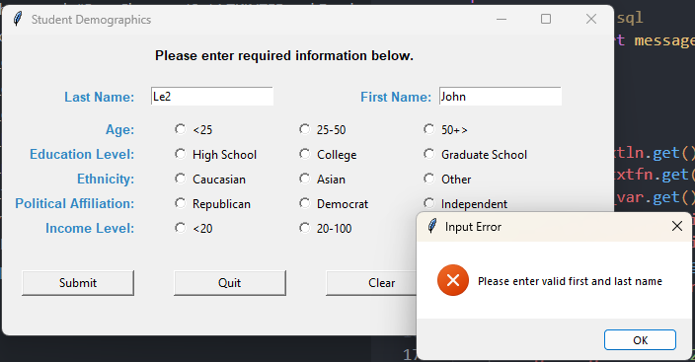

**Open the text file and print screen the contents below here.**

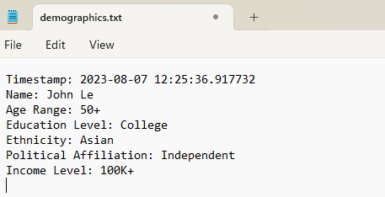

**Submit this document with the zipped app to the Module 8 final exam.**